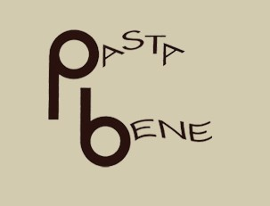

Your Organization Logo

EAT GREAT - DO GOOD FUNDRAISER
On [Your Approved Fundraiser Dates], every time you order, Pasta Bene will
donate 10% of your food and drink purchase to [Your Organization Name]
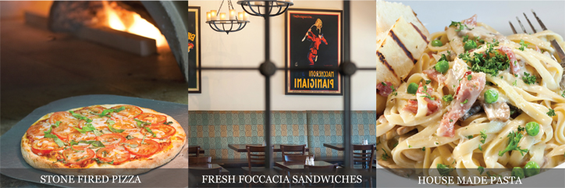

2565 Telegraph Avenue at Blake Street, Berkeley, CA 94704
510-845-2363 . www.pastabenebk.com
This coupon may not be combined with any special offers, discounts or promotions. . One flyer per diner or per multiple diners paying together required. . Catering excluded.

